**Shell Script Assignment**

Q 1. Create a script named “myscipt” in current directory to do the following.

1. Display “hello user”

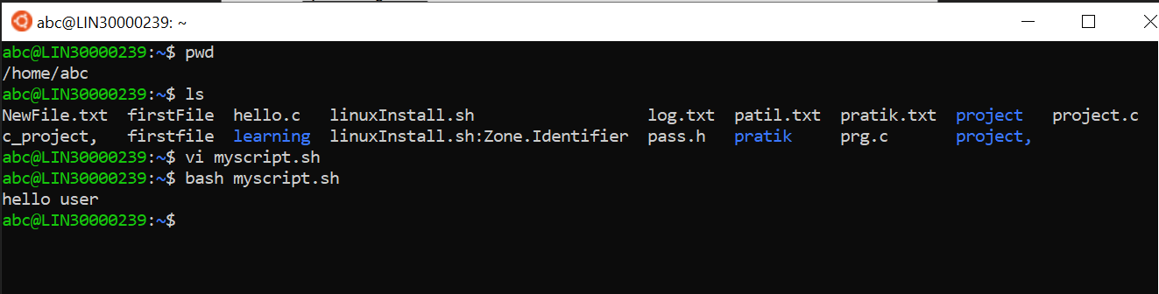

1. List files in current directory.

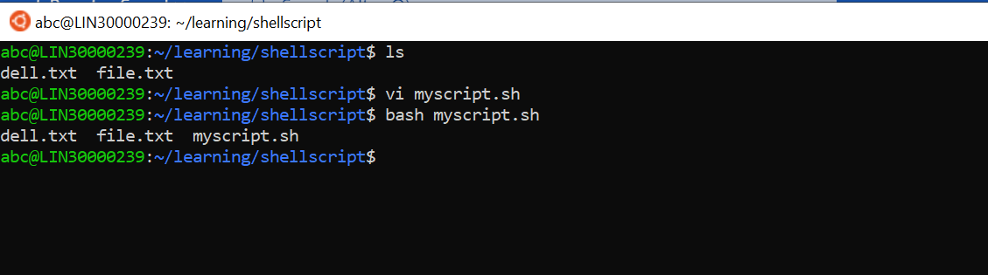

1. Name of logged in user

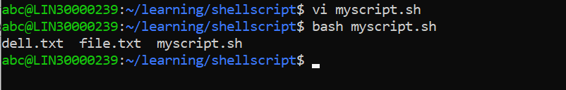

1. Date

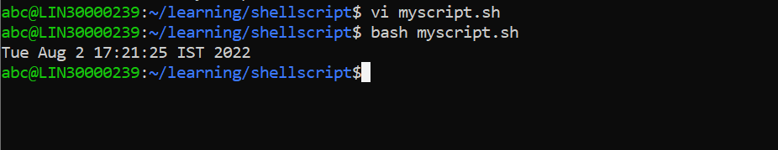

Q2. Add execute permission and run the script from

1. Current directory

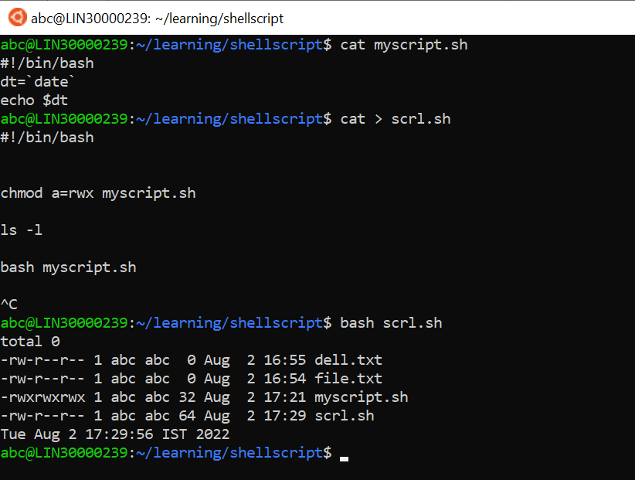

Q 3) Create a subdirectory named “test”

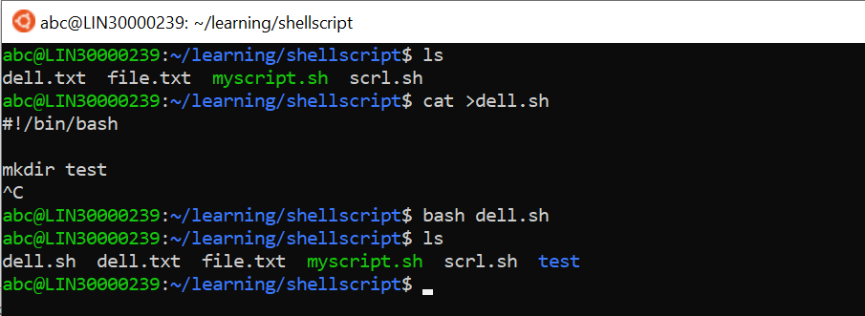

Q 4) Change to “test” directory. Run the script “myscript” [Hint: You will have to update PATH to include the directory containg script to run script from any location].